Rectangle Diagonal Theorem

Definition
# Source: AI Source: Provided by: [Data Path: Persons Table -> ID Column: 1, Name_En Column: Motasem Essam] -> From: [ChatGPT] on [7/25/2026]
The Rectangle Diagonal Theorem states:
The diagonals of a rectangle are congruent and bisect each other.
For rectangle $ABCD$, the diagonals are:
$$\overset{‾}{AC}$$
and
$$\overset{‾}{BD}$$
If they intersect at $O$, then:
$$\boxed{AC=BD}$$
and, because every rectangle is a parallelogram:
$$\boxed{AO=OC} \\ \boxed{BO=OD}$$
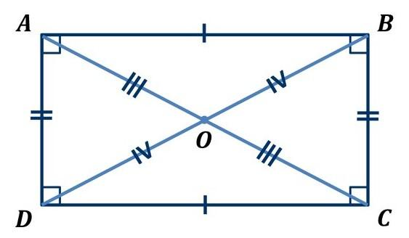
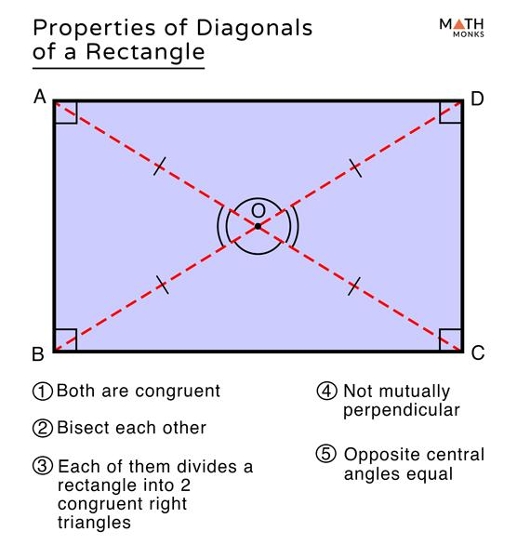
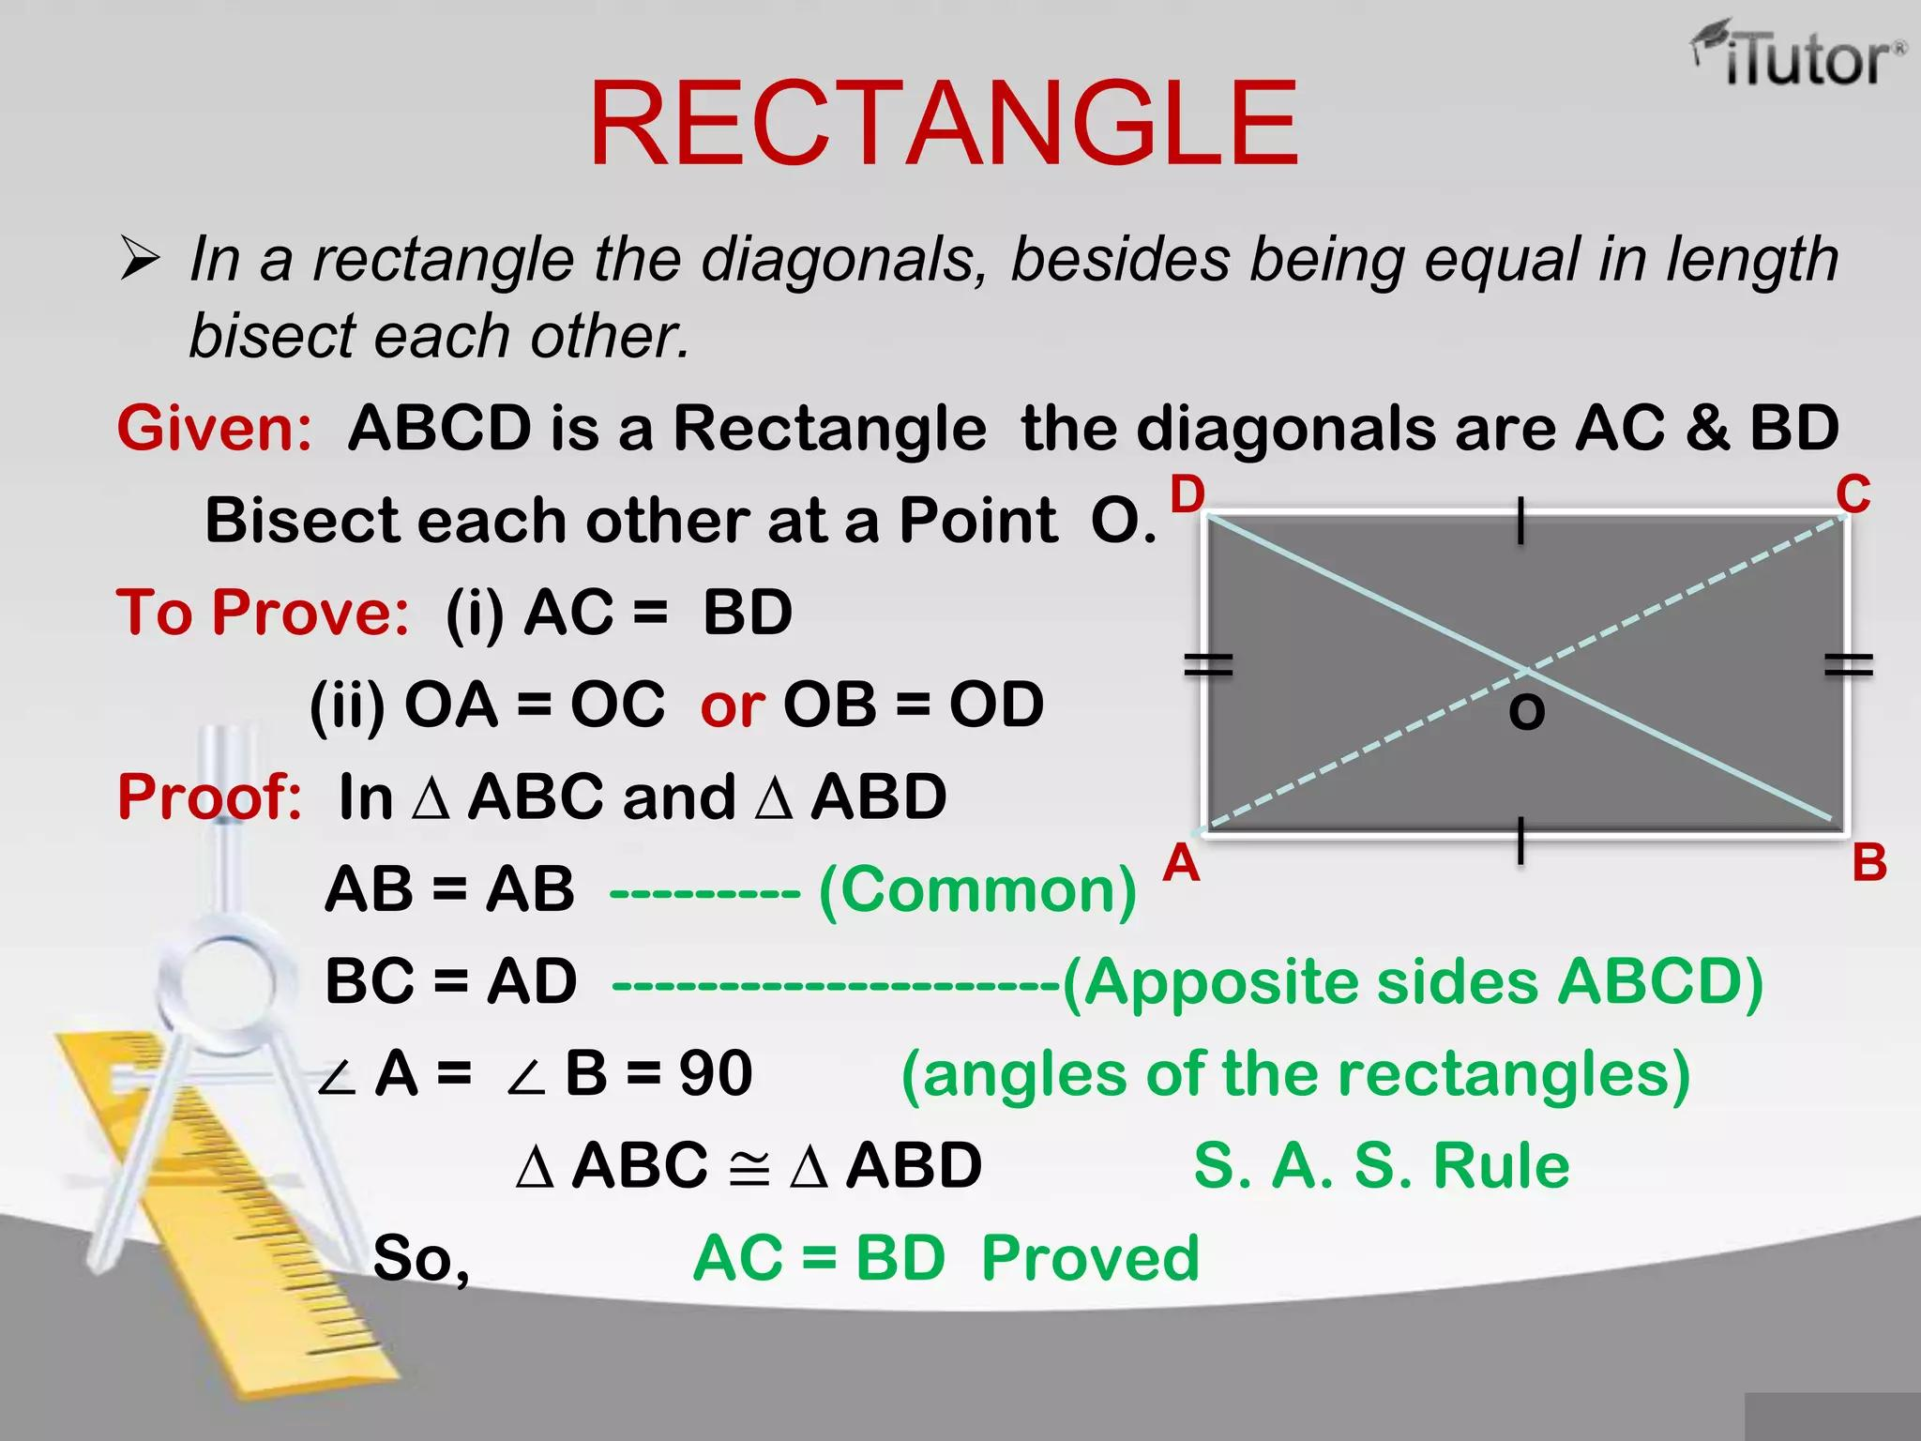
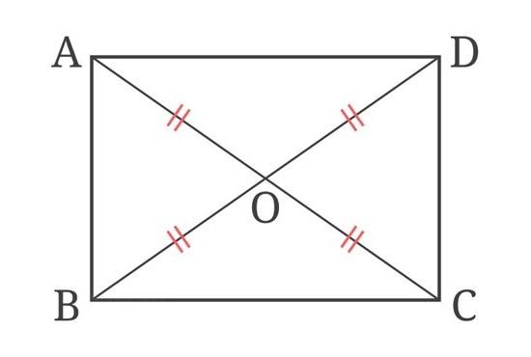

Fundamental Properties
# Source: AI Source: Provided by: [Data Path: Persons Table -> ID Column: 1, Name_En Column: Motasem Essam] -> From: [ChatGPT] on [7/25/2026]
For rectangle $ABCD$:
1. Diagonals are congruent
$$\boxed{AC=BD}$$
Both diagonals have the same length.
2. Diagonals bisect each other
If the diagonals intersect at $O$:
$$\boxed{AO=OC} \\ \boxed{BO=OD}$$
3. Each diagonal has the same midpoint
$$\boxed{midpoint⁡\left(AC\right)=midpoint⁡\left(BD\right)}$$
Thus, the intersection $O$is the midpoint of both diagonals.
4. Diagonal length
If the rectangle has width $w$and height $h$, then:
$$\boxed{d=\sqrt{w^{2}+h^{2}}}$$
Since both diagonals are congruent:
$$\boxed{AC=BD=\sqrt{w^{2}+h^{2}}}$$

Proof
# Source: AI Source: Provided by: [Data Path: Persons Table -> ID Column: 1, Name_En Column: Motasem Essam] -> From: [ChatGPT] on [7/25/2026]
Consider rectangle $ABCD$.
Because a rectangle is a parallelogram:
$$AB∥CD$$
and
$$AD∥BC$$
Also, all four angles are right angles:
$$∠A=∠B=∠C=∠D={90}^{∘}$$
To prove that the diagonals are congruent, consider triangles:
$$△ABC$$
and
$$△BAD$$
We have:
$$AB=AB$$
because it is a common side.
Also:
$$BC=AD$$
because opposite sides of a rectangle are congruent.
And:
$$∠ABC=∠BAD={90}^{∘}$$
Therefore:
$$△ABC≅△BAD$$
by SAS.
Corresponding sides are congruent:
$$\boxed{AC=BD}$$
Therefore, the diagonals of a rectangle are congruent.
Since a rectangle is also a parallelogram, its diagonals bisect each other:
$$\boxed{AO=OC} \\ \boxed{BO=OD}$$

Example 1 — Finding a Diagonal
# Source: AI Source: Provided by: [Data Path: Persons Table -> ID Column: 1, Name_En Column: Motasem Essam] -> From: [ChatGPT] on [7/25/2026]
A rectangle has:
$$w=8\text{ cm}$$
and
$$h=6\text{ cm}$$
The diagonal is:
$$d=\sqrt{8^{2}+6^{2}} \\ d=\sqrt{64+36} \\ d=\sqrt{100} \\ \boxed{d=10\text{ cm}}$$
Therefore:
$$\boxed{AC=BD=10\text{ cm}}$$

Example 2 — Using the Diagonal Theorem
# Source: AI Source: Provided by: [Data Path: Persons Table -> ID Column: 1, Name_En Column: Motasem Essam] -> From: [ChatGPT] on [7/25/2026]
Suppose the diagonals intersect at $O$, and:
$$AO=9\text{ cm}$$
Because the diagonals bisect each other:
$$AO=OC$$
Therefore:
$$\boxed{OC=9\text{ cm}}$$
The entire diagonal is:
$$AC=AO+OC \\ AC=9+9 \\ \boxed{AC=18\text{ cm}}$$
Because the diagonals are congruent:
$$\boxed{BD=18\text{ cm}}$$

Example 3 — Algebraic Form
# Source: AI Source: Provided by: [Data Path: Persons Table -> ID Column: 1, Name_En Column: Motasem Essam] -> From: [ChatGPT] on [7/25/2026]
Suppose:
$$AC=4x+2$$
and:
$$BD=6x-10$$
Since the diagonals of a rectangle are congruent:
$$AC=BD$$
Therefore:
$$4x+2=6x-10 \\ 12=2x \\ x=6$$
Thus:
$$AC=4\left(6\right)+2=26$$
and:
$$BD=6\left(6\right)-10=26$$
Therefore:
$$\boxed{AC=BD=26}$$

Coordinate Representation
# Source: AI Source: Provided by: [Data Path: Persons Table -> ID Column: 1, Name_En Column: Motasem Essam] -> From: [ChatGPT] on [7/25/2026]
For a rectangle with vertices:
$$A\left(x_{1} , y_{1}\right), B\left(x_{2} , y_{2}\right), C\left(x_{3} , y_{3}\right), D\left(x_{4} , y_{4}\right)$$
the diagonal lengths can be calculated using the distance formula:
$$AC=\sqrt{{\left(x_{3}-x_{1}\right)}^{2}+{\left(y_{3}-y_{1}\right)}^{2}} \\ BD=\sqrt{{\left(x_{4}-x_{2}\right)}^{2}+{\left(y_{4}-y_{2}\right)}^{2}}$$
For a rectangle:
$$\boxed{AC=BD}$$
The midpoint of each diagonal is also the same:
$$\boxed{\left(\frac{x_{A}+x_{C}}{2} , \frac{y_{A}+y_{C}}{2}\right)=\left(\frac{x_{B}+x_{D}}{2} , \frac{y_{B}+y_{D}}{2}\right)}$$

Important Distinction
# Source: AI Source: Provided by: [Data Path: Persons Table -> ID Column: 1, Name_En Column: Motasem Essam] -> From: [ChatGPT] on [7/25/2026]
The rectangle has two important diagonal properties:

Property | Rectangle
Diagonals bisect each other | ✓
Diagonals are congruent | ✓
Diagonals are perpendicular | Not generally
Diagonals bisect the vertex angles | Not generally
The fact that the diagonals are perpendicular belongs specifically to the rhombus/square case, not to a general rectangle.

Special Case: Square
# Source: AI Source: Provided by: [Data Path: Persons Table -> ID Column: 1, Name_En Column: Motasem Essam] -> From: [ChatGPT] on [7/25/2026]
A square is a special rectangle.
Therefore, its diagonals:
- are congruent,
- bisect each other,
- are perpendicular,
- bisect the vertex angles.
For a square with side length $a$:
$$\boxed{d=a\sqrt{2}}$$

Converse
# Source: AI Source: Provided by: [Data Path: Persons Table -> ID Column: 1, Name_En Column: Motasem Essam] -> From: [ChatGPT] on [7/25/2026]
A useful converse is:
If the diagonals of a parallelogram are congruent, then the parallelogram is a rectangle.
Thus:
$$\boxed{\text{Parallelogram}+\text{Congruent Diagonals}⇒\text{Rectangle}}$$
This is commonly used as a criterion for proving that a parallelogram is a rectangle.

Key Points
# Source: AI Source: Provided by: [Data Path: Persons Table -> ID Column: 1, Name_En Column: Motasem Essam] -> From: [ChatGPT] on [7/25/2026]
- A rectangle has two diagonals.
- The diagonals are congruent:
$$\boxed{AC=BD}$$
- The diagonals bisect each other:
$$\boxed{AO=OC, BO=OD}$$
- Both diagonals have length:
$$\boxed{d=\sqrt{w^{2}+h^{2}}}$$
- The diagonals are generally not perpendicular.
- A square satisfies all rectangle diagonal properties plus perpendicular diagonals.

Conclusion
# Source: AI Source: Provided by: [Data Path: Persons Table -> ID Column: 1, Name_En Column: Motasem Essam] -> From: [ChatGPT] on [7/25/2026]
The Rectangle Diagonal Theorem can be summarized as:
$$\boxed{\text{The diagonals of a rectangle are congruent and bisect each other.}}$$
For rectangle $ABCD$:
$$\boxed{AC=BD}$$
and if the diagonals meet at $O$:
$$\boxed{AO=OC, BO=OD}$$
Would you like a short proof or a worked example using the rectangle’s diagonal formula?

